Patient education

Software Requirements Specification

v1.0

7/5/2017

Norah

Lama

Thani

Shaden

Lead Software Engineer

Prepared for

King Khalid hospital PE-project

# Document Approval

The following Software Requirements Specification has been accepted and approved by the following:

|  |  |  |  |
| --- | --- | --- | --- |
| **Signature** | **Printed Name** | **Title** | **Date** |
|  | D. |  |  |
|  |  |  |  |
|  |  |  |  |

**Table of Contents**

**REVISION HISTORY**

**DOCUMENT APPROVAL**

**1. INTRODUCTION**

1.1 Overview

1.2 Scope

**2. GENERAL DESCRIPTION**

2.1 Product Perspective

2.2 Product Functions

2.3 User Characteristics

2.4 General Constraints

2.5 Assumptions and Dependencies

**3. SPECIFIC REQUIREMENTS**

3.1 External Interface Requirements

*3.1.1 User Interfaces*

*3.1.2 Hardware Interfaces*

*3.1.3 Software Interfaces*

3.2 Functional Requirements

*3.2.1 <Functional Requirement or Feature #1>*

*3.2.2 <Functional Requirement or Feature #2>*

3.3 Use Cases

*3.3.1 Use Case #1*

*3.3.2 Use Case #2*

3.4 Classes / Objects

*3.4.1 <Class / Object #1>*

*3.4.2 <Class / Object #2>*

3.5 Non-Functional Requirements

*3.5.1 Performance*

*3.5.2 Reliability*

*3.5.3 Availability*

*3.5.4 Security*

*3.5.5 Maintainability*

*3.5.6 Portability*

3.6 Inverse Requirements

3.7 Design Constraints

3.8 Logical Database Requirements

3.9 Other Requirements

**4. ANALYSIS MODELS**

4.1 Sequence Diagrams

4.3 Activity Diagram

**5. CHANGE MANAGEMENT PROCESS**

**A. APPENDICES**

A.1 Appendix 1

A.2 Appendix 2

# 1. Introduction

## 1.1 overview

To improve the efficiency and effectiveness of physician – patient interaction.

It is known that the bulk of patient-physician interaction is focused on educating patients about their illnesses. Health education plays a major role in the health care system as it impact patient outcomes to the extent that provider dedicate specialized professionals to carry on these tasks. The goal of patient education is to achieve shared decision making, improve understanding, improve treatment adherence and encourage self-management.

Although medical information are readily and easily accessible aided by the huge number of very sophisticated health education websites patients still trust their own physicians’ instructions and advises that often tailored to the patient specific conditions. However, as medicine is shifting toward specialized services more physicians are focusing on treating fewer illnesses aiming for better outcomes. Consequently, specialized physician and less frequently general practitioners end up repeating a few set of instructions when interacting with different patients. Such repetition, while effective and unique experience for each patient, it is less efficient and occasionally exhausting to the treating physician. In an increasingly automated digital environment aided by artificial intelligence we will work to develop a new web based application that provide patient with their own physician instructions. There are significant values in such model compared to the current practice summarized in the following points:

* Patients value:
  + Compared to verbal interaction or printed materials
    - Web-CPI is available at any time and place
    - Better retention as it can be repeated many times
    - Better understanding as it can integrate multimedia including patient education video and animation
    - Easily spread as it can be shared by the patients friends and family via social media
  + Compared to Google search and other health websites
    - Own physician approved instructions
    - Physician accountability
    - Instructions/ education is customized to local patients population (language, available treatment, local culture…etc)
* Physician value:
  + Web-CPI improves the physician-patient interaction time by providing alternative to detailed instruction and education
    - Physician can treat more patients per unit of time
  + Are less emotionally exhausting to repeat
  + Are available everywhere
  + Can be easily modified and update the physician
  + Can minimizes patient to patient instruction variability’s that are provided by the same condition and same physician
  + Can provide better quality instructions by sharing other more experienced physicians instruction and evidence-based resources
  + Physician can share own instructions with his patients or the public via social media
  + Help in promoting the physician brand and interaction experience when shared by their patients via social media

## 1.2 Scope

*there are three users for our application ( Doctor , patient , health center staff )*

* *Doctor / health center staff*

*Any doctor/ health center staff from any hospital have admin promotion to login .*

* *Patient*

*patients or any person cares about health .*

## 1.3 Definitions, Acronyms, and Abbreviations

*This subsection should provide the definitions of all terms, acronyms, and abbreviations required to properly interpret the SRS. This information may be provided by reference to one or more appendixes in the SRS or by reference to other documents.*

# 2. General Description

## 2.1 Product Perspective

*This subsection of the SRS puts the product into perspective with other related products or*

*projects. (See the IEEE Guide to SRS for more details).*

## 2.5 Assumptions and Dependencies

*This subsection of the SRS should list each of the factors that affect the requirements stated in the SRS. These factors are not design constraints on the software but are, rather, any changes to them that can affect the requirements in the SRS. For example, an assumption might be that a specific operating system will be available on the hardware designated for the software product. If, in fact, the operating system is not available, the SRS would then have to change accordingly.*

# 3. Specific Requirements

*This will be the largest and most important section of the SRS. The customer requirements will be embodied within Section 2, but this section will give the D-requirements that are used to guide the project’s software design, implementation, and testing.*

*Each requirement in this section should be:*

* *Correct*
* *Traceable (both forward and backward to prior/future artifacts)*
* *Unambiguous*
* *Verifiable (i.e., testable)*
* *Prioritized (with respect to importance and/or stability)*
* *Complete*
* *Consistent*
* *Uniquely identifiable (usually via numbering like 3.4.5.6)*

*Attention should be paid to the carefuly organize the requirements presented in this section so that they may easily accessed and understood. Furthermore, this SRS is not the software design document, therefore one should avoid the tendency to over-constrain (and therefore design) the software project within this SRS.*

## 3.1 External Interface Requirements

### 3.1.1 User Interfaces

### 3.1.2 Hardware Interfaces

### 3.1.3 Software Interfaces

## 3.2 Functional Requirements

|  |  |  |  |
| --- | --- | --- | --- |
| UNIQUE ID | PRIORITY WEIGHT | | REQUIRMENT |
| REQ-1 | high | **1.The users (Doctor , Admin and patient) shall be able to register an account on the system.** | |
| REQ-2 | high | **2.The users (Doctor , Admin and patient) shall log into the system to be able to use the system.** | |
| REQ-3 | high | **3- The user (Doctor , Admin and patient) shall be able to logout from the system**. | |
| REQ-4 | high | **4-The system shall allow the user (Doctor or Admin) to view articles on a specific title of subjects .**   * This feature is very important other users to be able to display all the topics that have been written about. There is a search for the possibility of user access to a particular article to be able to make use of the system and to facilitate them, and also an edit feature for editing on the article whether deleted or updated to give the system more efficient users. | |
| REQ-5 | high | **5-** | |
| REQ-6 | high | **6-** | |

## 3.3 Use Cases

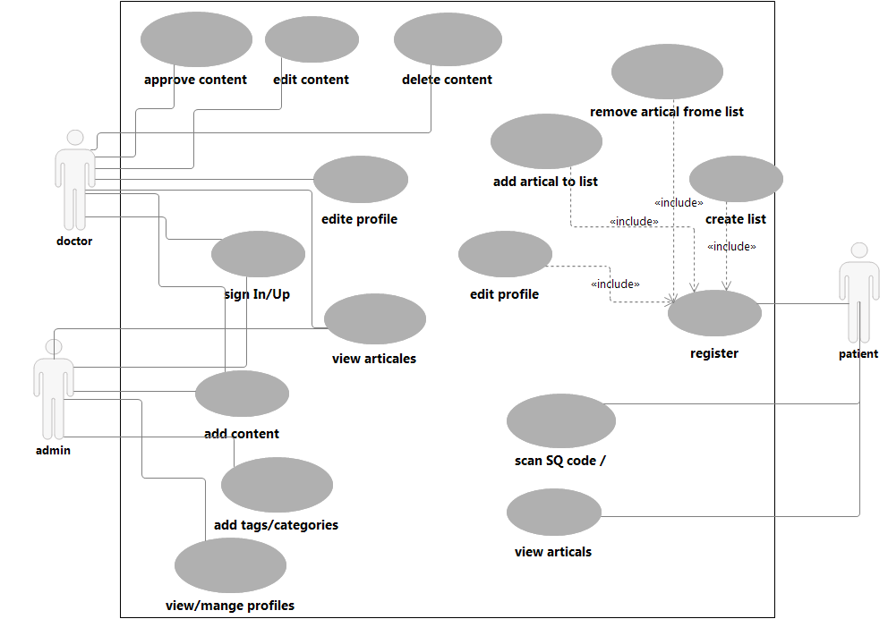

### 3.3.1 View Article

|  |  |  |
| --- | --- | --- |
| **Use Case Description** | | |
| **System:** Doctor | |  |
| **Use Case name:** View Article | |  |
| **Primary actor:** Doctor , Admin, patient | **Secondary actor(s):** none. | |
| **Description:** Viewtobe able all the articlesenteredbyhim. | | |
| **Relationships**   * **Includes:** Signin**.** * **Extends:** Edit **,** Delete**.** | | |
| **Pre-conditions:** Doctor is signed in and have the right to view articles and he can edit or delete content . | | |
| **Steps:** 1. Sign in to go to home page.  2.In home page click button View to go to View page.  3.Then , the user able to see articles and update on it. | | |
| **Alternative and exceptional flows:**  If the search is not found then a message appears on the page to try to enter the correct title. | | |
| **Post-conditions:** Information/modification entered by the doctor are appropriately stored in the database. | | |

### 3.3.2 edit profile

|  |  |  |  |  |
| --- | --- | --- | --- | --- |
| **Use Case Description** | | | | |
| **System:** Home page | | |  | |
| **Use Case name:** edit profile | | |  | |
| **Primary actor:** doctor | **Secondary actor(s):** | | | |
| **Description:** this page is get the doctor control for own profile and change Information also can add picture | | | | |
| **Relationships**   * **Includes:** * **Extends:** | | | | |
| **Pre-conditions:** login | | | | |
| **Steps:** | | | | |
| **Primary Actor (mention name)** | | **System** | | **Secondary Actor(s) (if applicable)** |
| 1. **When The doctor is log in the doctor will be in home page** 2. **The doctor press edit profile button** 3. **The doctor press sign out** 4. **The doctor press add page** 5. **The doctor press view page** | | **2.1 the system allow doctor to change profile**  **3.1 the system will be in sign in page**  **4.1 the system allow doctor to move to add page**  **5.1 the system allow doctor to move to view page** | |  |
| **Alternative and exceptional flows:** | | | | |
| **Post-conditions:** | | | | |

### 3.3.3 Sign Up

|  |  |
| --- | --- |
| **Use Case Description** | |
| **Use Case name: Sign Up** |  |
| **actor(s): patient** | |
| **Description: a user must register with the application before they are able to use it . Registration primarily consists of entering am email address for verification and creating a password .** | |
| **Trigger : the user has an account .** | |
| **Pre-conditions: a user is not a member of the system .** | |
| **Post-conditions :**   * **Success**   **The user entered successful information and is returned to the home page to log in .**   * **Failure**   **User is unable to log in for one or more reasons and is returned to the home page .** | |
| **Normal flow :**  **U1:** User navigates to the homepage and selects the ‘Sign Up ‘ .  **S1:** System displays the registration screen.  **U2:** User enters their information, and the conformation password.  **S2:** System validates that the email does not already exists. If it does not, a new user is created and a confirmation email is sent with a confirmation link that needs to be selected before the user is allowed to enter the site.  **U3:** User checks their email site for the email that the system sent and gets the confirmation link. The user selects this confirmation link.  **S3:** System accepts the confirmation link and requests the user to log in using their email and password. | |
| **Alternative and exceptional flows:**   * Cancel Registration  1. The user selects the cancel option.   2)The system returns the user to the home page without the user being logged in and any information entered has been erased.   * Invalid Information Entered   1)User clicks submit after entering information system asked for.   1. System displays information with appropriate message to correct invalid information. 2. User re-enters information. | |
| **Priority : High** | |
| **Frequency of use : Every time the user wants to create account .** | |

### 3.3.4 Log in

|  |  |
| --- | --- |
| **Use Case Description** | |
| **Use Case name: Login** |  |
| **actor(s): admin and doctor** | |
| **Description: users will be prompted to login with their email and password before they can use the system .** | |
| **Trigger : the user logs in the authenticate his or her role in the system and to perform a task in the system .** | |
| **Pre-conditions: a user account has been created for the user .** | |
| **Post-conditions :**   1. **The user is logged in to the system .** 2. **The user has access to the functions of the system .** | |
| **Normal flow :**   1. **Use case begins when user enters the application .** 2. **User clicks on “Login”.** 3. **The system displays a form for the user to input their login information**  * Email * Password  1. **The system will check if the details are correct** . | |
| **Alternative and exceptional flows:**  **4a. the system determines that the password is incorrect for the email entered.**   1. **The system prompts the user to re-enter the password .** 2. **The system provides the option for the user to retrieve a forgotten password .**   **4b. user provides invalid login information .**   1. **The system displays an error message .**   **4c. user does not have account in the system .** | |
| **Priority : High** | |
| **Frequency of use : Every time the user wants to access the system .** | |

### 3.3.4 add article

|  |  |  |  |  |
| --- | --- | --- | --- | --- |
| **Use Case Description** | | | | |
| **System:** patient education phone app | | |  | |
| **Use Case name:** add article | | |  | |
| **Primary actor:** doctor/admin | **Secondary actor(s):** | | | |
| **Description:** the use case describe how to add new article to the system/ database . | | | | |
| **Relationships**   * **Includes:** * **Extends: add photo ,add video/hyperlink** | | | | |
| **Pre-conditions:** login | | | | |
| **Steps:** | | | | |
| **Primary Actor (doctor)** | | **System** | | **Secondary Actor(s) ()** |
| 1. The doctor press add button from home bag . 2. The doctor type the title and content then press add Butten. | | **1.1** the system display add form with add photo ,video options.  **2.1** the system add article to database .  **2.2** the system display successes message and return user to home page. | |  |
| **Alternative and exceptional flows:**  **1.** no title  If doctor press add in step 2 with out adding title  The system display notification with “you forget title” message .  **2.**cancel  If doctor cancel before adding the system return to home page and display canceling message . | | | | |
| **Post-conditions:** the article added to database | | | | |

### 3.4 Classes / Objects

### 3.4.1 <Class / Object #1>

3.4.1.1 Attributes

3.4.1.2 Functions

<Reference to functional requirements and/or use cases>

### 3.4.2 <Class / Object #2>

…

## 3.5 Non-Functional Requirements

*Non-functional requirements may exist for the following attributes. Often these requirements must be achieved at a system-wide level rather than at a unit level. State the requirements in the following sections in measurable terms (e.g., 95% of transaction shall be processed in less than a second, system downtime may not exceed 1 minute per day, > 30 day MTBF value, etc).*

### 3.5.1 Performance

### 3.5.2 Reliability

### 3.5.3 Availability

### 3.5.4 Security

### 3.5.5 Maintainability

### 3.5.6 Portability

## 3.6 Inverse Requirements

*Traceability between Use Case and Function/Feature*

## 3.7 Design Constraints

*Specify design constrains imposed by other standards, company policies, hardware limitation, etc. that will impact this software project.*

## 3.8 Logical Database Requirements

*Will a database be used? If so, what logical requirements exist for data formats, storage capabilities, data retention, data integrity, etc.*

## 3.9 Other Requirements

*Catchall section for any additional requirements.*

# 4. Analysis Models

*List all analysis models used in developing specific requirements previously given in this SRS. Each model should include an introduction and a narrative description. Furthermore, each model should be traceable the SRS’s requirements.*

## 4.1 Sequence Diagrams

* Sign Up

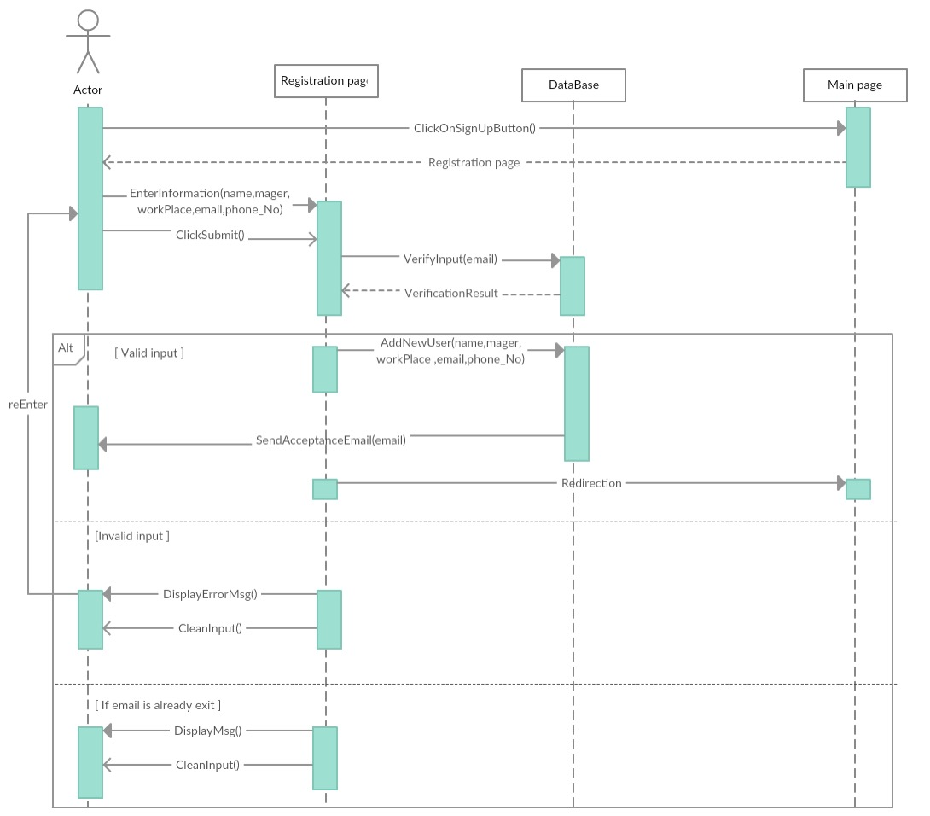

* Login

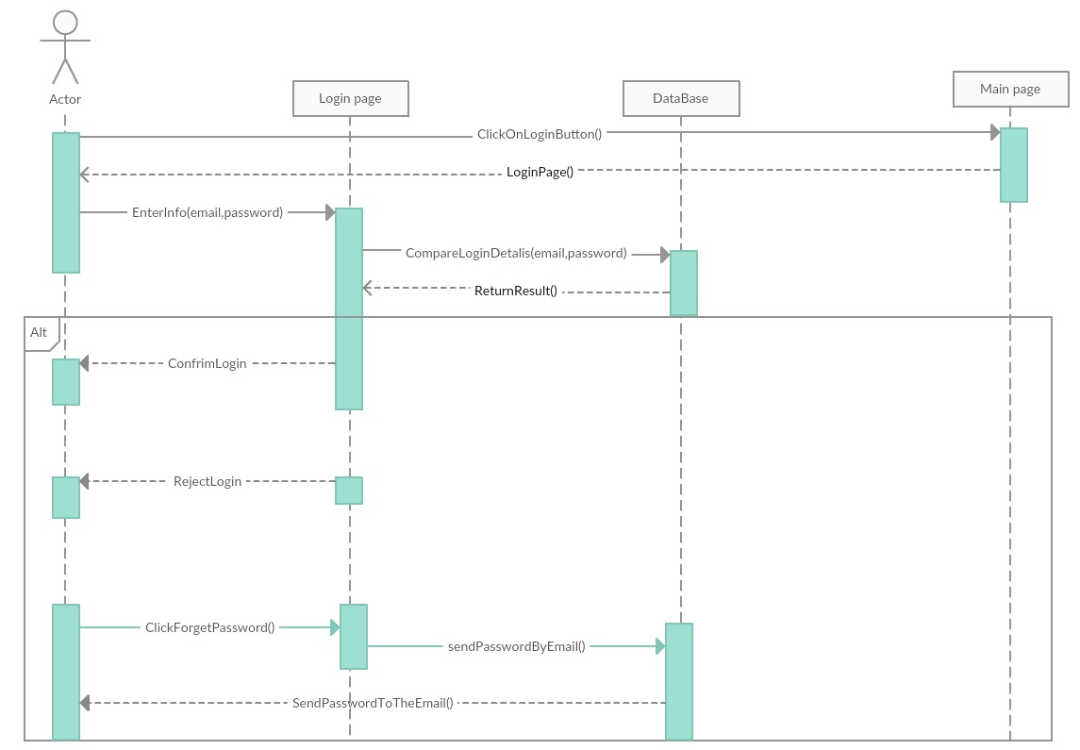

* Home

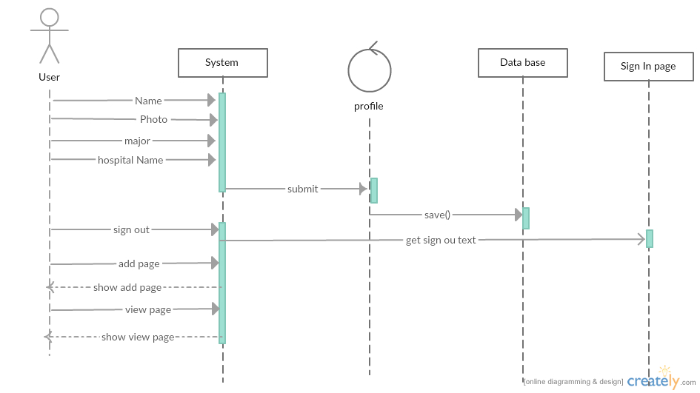

## View

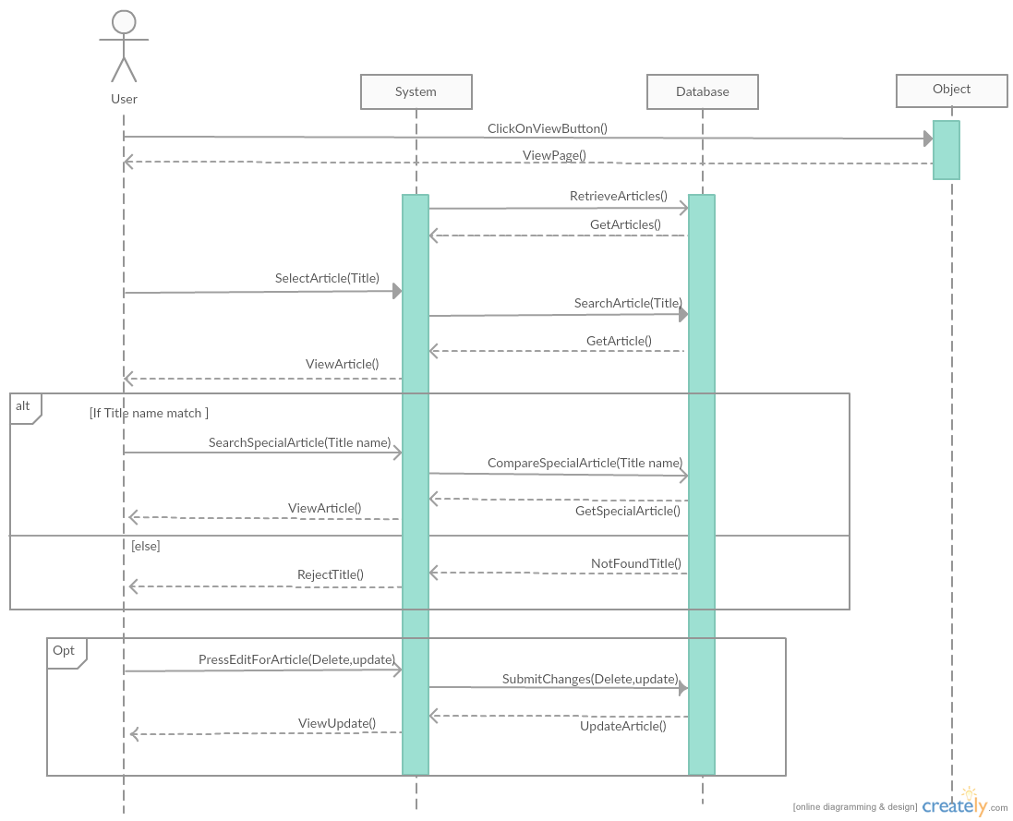

* Add article

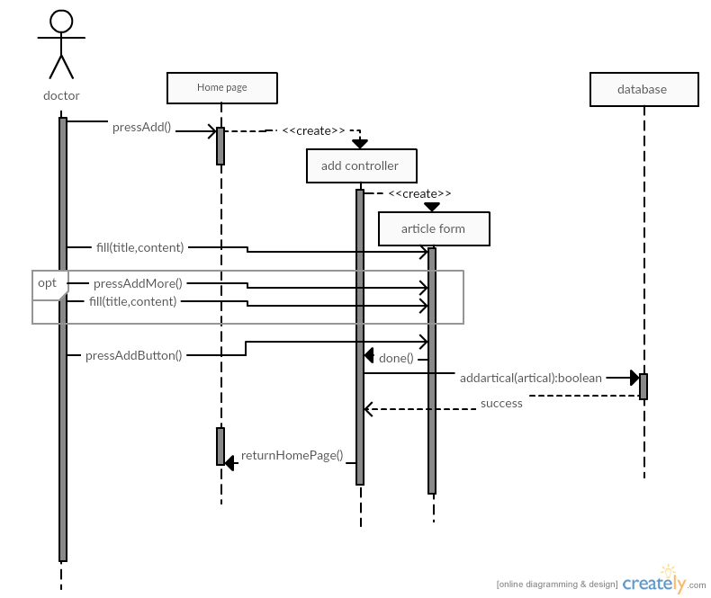

# 5. Change Management Process

*Identify and describe the process that will be used to update the SRS, as needed, when project scope or requirements change. Who can submit changes and by what means, and how will these changes be approved.*

# A. Appendices

*Appendices may be used to provide additional (and hopefully helpful) information. If present, the SRS should explicitly state whether the information contained within an appendix is to be considered as a part of the SRS’s overall set of requirements.*

*Example Appendices could include (initial) conceptual documents for the software project, marketing materials, minutes of meetings with the customer(s), etc.*

## A.1 Appendix 1

## A.2 Appendix 2